Use-Case Realization Report
Delete Lesson

Issue <3.0>
Revision History
Date | Issue | Description | Author
01/08/09 | 1.0 | Initial Version | Haiyang
16/09/09 | 2.0 | Revised after peer review | Haiyang
12./10/09 | 3.0 | Modified the document based on Open Source Review | Rajendran Kumaraguru

Table of Contents
1. Brief Description 4
2. Flow of Events 4
2.1 Standard Flow 4
2.2 Exception Flow 4
3. Interaction Diagrams 4
3.1 Collaboration Diagram for Delete Lesson 4
4. Participating Objects 4
5. Class Diagrams 5
5.1 Class Diagram for Delete Lesson 5
6. Derived Requirements 5

Use-Case Realization Report
Delete Lesson

Brief Description
Portal admin will be able to delete the lesson which is already uploaded in to the system. Upon completion of the expiry portal admin will be deleting the lesson.

Flow of Events

Standard Flow
- Portal Admin login into the system.
- Select the site to be deleted.
- Validate fields will be validating the field data before proceeding to the deletion operation.
- Delete the site from the site.
- Upon deletion of the site system will show the success or failure to portal admin.

Exception Flow
  - If the lesson is not available for the selected lesson the exceptions message will be thrown to the user.
  - If there is any error while validating the field then respective error message will be shown to the portal admin.

Interaction Diagrams

Collaboration Diagram for Delete Lesson
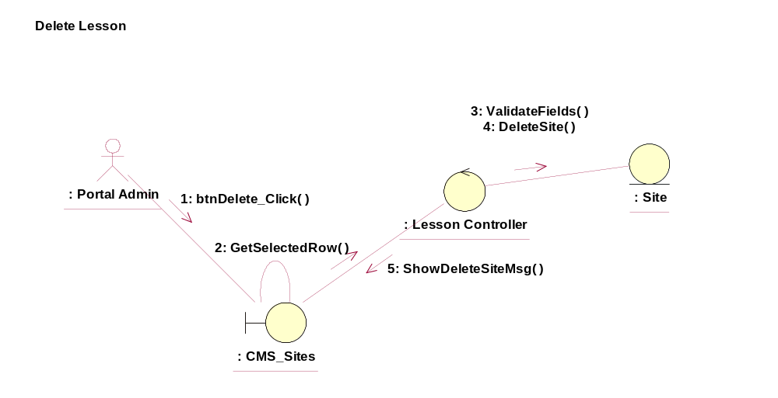

Participating Objects
: : CMS_Sites
This entity is the lesson object, it belongs to JMD.
:
: Lesson Controller
This is the controller to upload, add, delete and modify lessons.
: Site
Adding the site upon creation of the folder.

Class Diagrams

Class Diagram for Delete Lesson
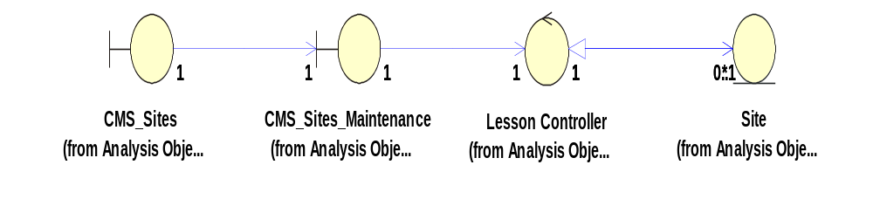

Derived Requirements
[enter the derived requirements here]

